 20200120 Release Notes
contents
1. Change Request 2
1.1 Newly added payment overtime function: After the customer scans the code to pay overtime, the overtime record is uploaded to the BackStore payment overtime report. 2
1.2 Modification Change the countdown of whether to print a small ticket pop-up window from 5 seconds to 10 seconds. 2
2. Bug Fix 3
2.1 Fix the problem of fast switching of coupons 3
2.2 Fix the crash issue of Food Workshop. 3
2.3 Repair the scanning platform hardware problems caused the scanning platform to fail to scan codes 3
2.4 Repair the abnormal printing text caused by the printer hardware problem 3

Change Request

Newly added payment overtime function: After the customer scans the code to pay overtime, the overtime record is uploaded to the BackStore payment overtime report.
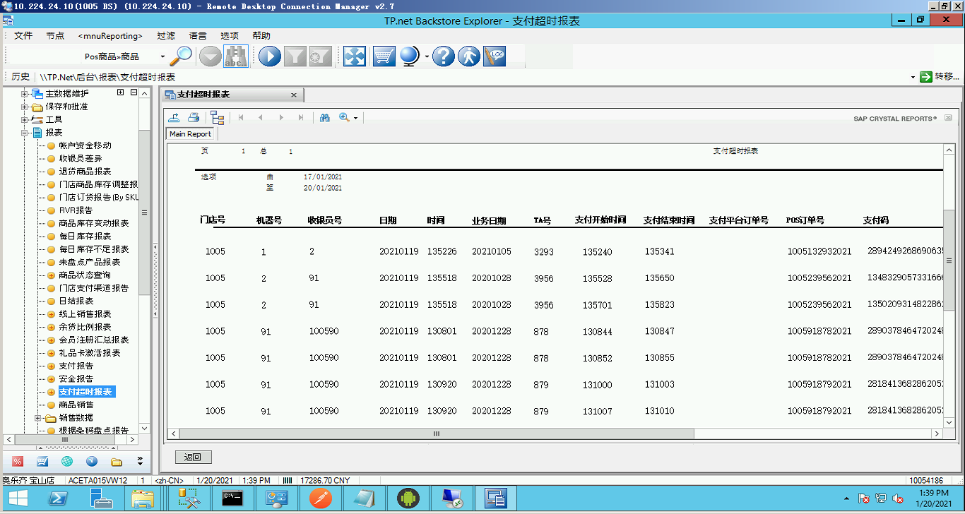

Modification Change the countdown of whether to print a small ticket pop-up window from 5 seconds to 10 seconds.
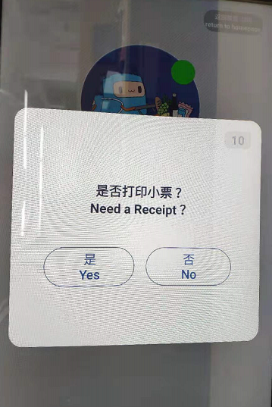

Bug Fix

Fix the problem of fast switching of coupons
Description of the problem: When two coupons are clicked quickly in a row, the price of the product calculates the discount for multiple times, resulting in a difference between the settlement amount and the actual amount.

Fix the crash issue of Food Workshop.
Description of the problem: The product in the food workshop product category is empty. Choose other product categories and add products, causing a crash problem.

Repair the scanning platform hardware problems caused the scanning platform to fail to scan codes
Description of the problem: Unstable voltage on the serial port of the scanner causes the barcode to be unrecognized after the APP scanner is powered off

Repair the abnormal printing text caused by the printer hardware problem
Description of the problem: Unstable voltage on the serial port of the scanner causes the APP printer to fail to print receipts after power off, indicating that the printed text cannot be recovered.

